Catalysts

# Introduction

Catalysts increase the rate of a chemical reaction by providing an alternative reaction pathway which has a lower activation energy (Ea). When a catalyst is present a greater percentage of collisions occur with energy equal to or greater than the activation energy.

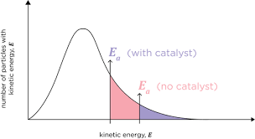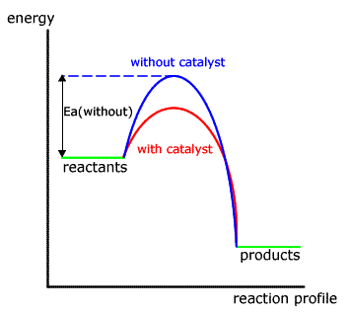

Figure 1a) energy profile diagram showing a reaction profile with and without a catalyst.

Figure 1b) Maxwell Boltzmann distribution with and without a catalyst. The blue shaded area shows the proportion of particles with energy equal to or great than the activation energy (the minimum energy required for a successful collision). When a catalyst is used the red plus blue shaded area show the proportion of particles with energy equal to or greater than the activation energy.

Even though catalysts do take part in a reaction, they are not consumed in the reaction. For this reason catalysts are written above or below the reaction arrow in a written equation. It also means that in some cases a catalyst can be recovered and reused.

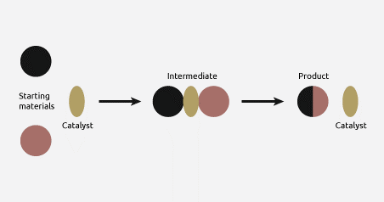

# Examples of catalysts

Watch the videos and record examples of different catalysts and the reactions they catalyse. Some of the reactions are covered in multiple videos. You may also need to use your textbook or do a google search to fill in missing details. Each example should include an equation for the reaction, the catalysts used and additional notes such as why a catalyst is used, are there alternative catalysts, any points of interest.

Video 1: <https://www.youtube.com/watch?v=m_9bpZep1QM>

Video 2: <https://www.youtube.com/watch?v=A_PhvIktMOw>

Video 3: <https://www.youtube.com/watch?v=rlH1ym916Fo>

|  |  |  |
| --- | --- | --- |
| Catalyst | Reaction | Additional notes |
|  | Haber process |  |
|  | Contact process |  |
|  | Catalytic converters on car exhausts |  |
|  | Nylon production |  |
| Enzymes  Different roles of enzymes:  Factors effecting enzyme activity – list here the properties that affect the activity of enzymes: | | |
|  | Protease |  |
|  | Carbohydrase |  |
|  | Lipase |  |
|  | Catalase |  |